Tire choices for my 16" wheels:

Nokian says:

The Nokian Hakkapeliitta 2, the Nokian Hakkapeliitta CQ friction tyres and the studded Nokian Hakkapeliitta C2 are designed for Nordic conditions, whereas the Nokian Hakkapeliitta NRW and the Nokian Hakkapeliitta CS are designed for Western European driving conditions.

Tires in yellow are recommended.

Brand | Size | Model | Revolutions Per Mile | Load Rating | Rim Widths | Type of Tire | Vendor Source | Tire Size Calculator
(target) |  |  | 780 to 820 | 1600lbs | 6.5" included
Nokian | 205/65R16 | Hakkapeliitta CS  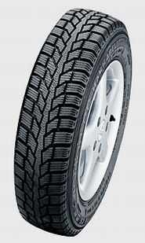 | 790  26.5" |  | 5.5-6.5 | Winter tire but with a year-round rubber compound so this is really an all-season all-purpose tire. | Etires exact size not listed http://www.nokiantires.com/newsite/tires_popup.cfm?id=15 But you could go to http://www.etires.com/showSizes.jsp?manufacturer=nokian&category=SNOWS&group=HAKCS and then ask them to get this size. Or you could go to http://www.tirefactory.net/HakCSSpecs.htm and ask them to get this size. You can confirm that this size exists here: http://www.reifen.de/nokian/hkpl_cs/205-65_r16c_107-105s.html | 785.2 is the calculated revs per mile but the actual revs mile will be different.
Nokian | 215/65R16 | Hakkapeliitta CS | 774  27" |  | 6-7" |  | Etires exact size not listed but this size is listed at http://www.tirefactory.net/HakCSSpecs.htm http://www.nokiantires.com/newsite/tires_popup.cfm?id=15 | 770 is the calculated revs per mile but the actual revs mile will be different.
Goodyear | 215/65R16 | Wrangler HP  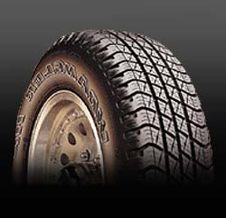 | 774 revs per mile  27" tall rated tire height | 98 | OK | On/off road. |  | 770 is the calculated revs per mile but the actual revs mile will be different. The factory says the actual revs per mile is 774.
Nokian | 195/75/16 | Hakkapeliitta CS | 756 revs per mile  27.5 |  | To 6" | Winter tire but has year-round rubber compound so can be used year round | http://www.etires.com/tireSpec.jsp?specID=3422 http://www.nokiantires.com/newsite/tires_popup.cfm?id=15 | 756 is the calculated revs per mile but the actual revs mile will be different.
Nokian | 225/60/16 | WR | 782 | 98
Nokian | 215/65/16 | WR | 27" | 98 | 6-7.5 | All weather passenger car | http://www.etires.com/tireSpec.jsp?specID=3415
Nokian | 215/65R16 | WR A.W.P 2 SUV | 770 |  |  | Four season | 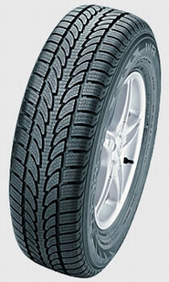 http://www.nokiantires.com/newsite/tires_popup.cfm?id=17
Nokian | 225/60/16 | NWR | 782 | 98
Nokian Says This Tire not offered in this size!!!!!! | 225/60/16 | Hakkapeliitta CS | 27" |  | 6-7" |  | Etires exact size not listed http://www.nokiantires.com/newsite/tires_popup.cfm?id=15 . But I am not sure where I got this size from!!!!! Because it is not on the Nokian site. | 781 is the calculated revs per mile but the actual revs mile will be different.
Dunlup | 225/60WR/16 | SP Sport 9000 | 783 | 98 | 6.5
B.F. Goodrich | 205/55-16 | Unkown, touring | 839
B.F. Goodrich | 225/60/16 | Unkown, touring | 782
Michelin | 215/60-16 | X-One | 805 | 1477
Michelin | 215/65/16 | X-One | 782 | 1565
Dunlop |  | SP 40 A/S | 786 | 97
Yokahama
Nokian |  | WR
Nokian | 205/50R16 | Hakkapeliitta 2 | 24.1 | 87T | 5.5-7.5 | Aggressive snow tire | 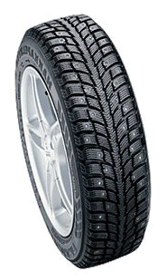
Nokian | 215/55R16 | Hakkapeliitta 2 | 25.3 | 97T | 6.0 - 7.5 | Aggressive snow tire
Nokian | 225/60R16 | Hakkapeliitta 2 | 26.6 | 98T | 6.0 - 8.0 | Aggressive snow tire | http://www.etires.com/tireSpec.jsp?specID=384
Nokian | 215/65R16 | Hakkapeliitta 2 | 27 | 98T | 6-7.5 | Aggressive snow tire |  | 770 is the calculated revs per mile but the actual revs mile will be higher.
Nokian | 235/60R16 | Hakkapeliitta 2 | 27.1 | 100T | 6.5-8.5 | Aggressive snow tire
Nokian | 215/70R16 | Hakkapeliitta SUV | FALL 2004
Nokian | 215/65/16 | Hakkapeliitta C2 | 27" |  | 6-7" |  | http://www.nokiantires.com/newsite/tires_popup.cfm?id=13&w=1 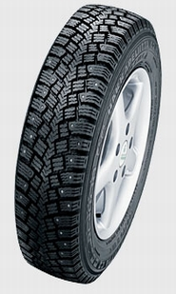 | 770 is the calculated revs per mile but the actual revs mile will be higher.

There is a tire that Etires calls the Happ LT but there are not sizes suitable.
There is a tire that Etires calls the Happ 10 but there are no sizes suitable listed.
Etires lists the CS

